Wildflower Vale Winery
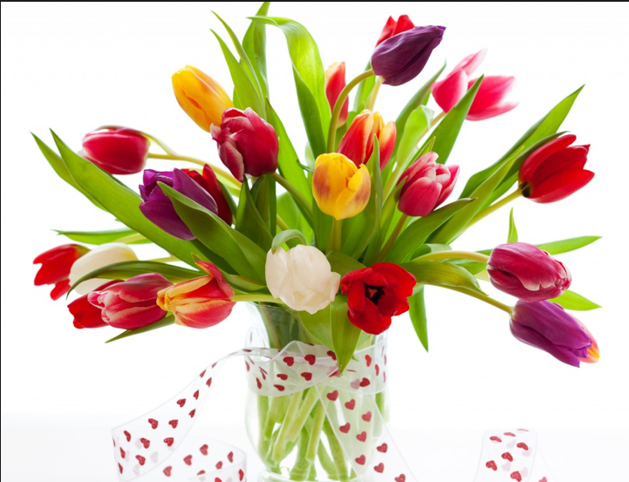
Metcalf Rd
NSW


Wildflower Vale Winery
Report to the Board

The following table and chart show the figures for the period March 12 to June 16. These figures were kindly presented by Peter Faulks and we are forever grateful for his/her expertise in this area.

BRAND | Costs | Sales
Chardonnay | $11,400 | $15,400
Riesling | $10,200 | $12,560
Cabernet Sav | $12,500 | $18,450
Pinot Noir | $10,000 | $13,500
Claret | $11,200 | $16,240

Any comments on this report should be directed to the Chairman in writing

